**Communication Management Plan Version 1.0**

**Date: May 27, 2020**

**Project Name:** Board Game Development

1. **Stakeholder communications requirements:**

The main objective of communication management is to identify the information need to be communicated with the stakeholders and how to communicate to them and to determine person responsible for communication at regular intervals. It is also used to provide weekly check-in meetings and high level timeline/budget/progress update via mail. Because this project involves many people from all over the company as well as outside suppliers, the project team will use surveys, interviews, checklists, other tools n techniques to determine the communication requirements for various stakeholders.

|  |  |
| --- | --- |
| **Resource** | **Key Project Information** |
| Project Sponsor | Project approvals during initial phase |
| Project Manager | Project Status &Progress reports throughout project planning |
| Team Lead | Daily meeting minutes, Team schedule during project execution |
| Programmer | Design documents /deliverable |
| QA Lead | Test results and quality reports |

1. **Communications summary:**

The following table summarizes the various stakeholders, communications required, the delivery method or format of the communications, who will produce the communications and when they will be distributed or the frequency of the distribution. All communications produced will be archived and available on the project web site. The project team will use various templates and checklists to enhance the communications.

|  |  |  |  |  |
| --- | --- | --- | --- | --- |
| **Stakeholders** | **Communications Name** | **Delivery Method/Format** | **Responsibility** | **Due/Frequency** |
| Project team | Monthly Project Status Meetings | Report of the status of the project including activities, progress, costs and issues | Neelesh Saladi, Tejaswi Reddy Kandula,  Vineetha Yenugula,  Revanth Davuluri,  Bharath Kumar Gandhasiri | Monthly |
| Project steering committee | Weekly status report | Hard copy and short meeting | Revanth Davuluri. | Weekly  Thursday-10 a.m. |
| Sponsor and champion | Monthly status report | Hard copy and short meeting | Vineetha Yenugula. | Monthly |
| Development Team | Project announcement | Memo, e-mail, intranet site,Slack, and announcement at department meetings | Tejaswi Reddy Kandula, Neelesh Saladi | May 27, 2020 |
| Project team | Weekly status report | Short meeting | Neelesh Saladi, Tejaswi Reddy Kandula,  Vineetha Yenugula,  Revanth Davuluri,  Bharath Kumar Gandhasiri | Weekly  Wednesday-3p.m. |
| Game Engineer team | Weekly status report | e-mail, intranet site, tools and announcement at department meetings | Neelesh Saladi, Tejaswi Reddy Kandula,  Vineetha Yenugula | Weekly Thursday – 5pm |

1. **Comments/Guidelines:**

* Make sure people understand your communications. Use commonsense techniques to check the comprehension such as having them explain what you mean in their own words.
* Schedule meetings and have direct conversation and all documents should be shared only through SharePoint.
* Email is preferred formal way of communication to convey the information.
* Face to face conversation for every milestone if possible.
* Official approval/Sign off documentation for every deliverable.
* One should follow formal procedure for updating communication management plan.
* Use the titles and dates of documents in e-mail headings and have acknowledge receipt.
* There should be proper reason and approval from project manager to update the plan.
* Version will be updated with the update in plan.
* One should set a feature of automated mail if you are not available for work due to personal reason along with the details of person to be contacted in your absence.

1. **Escalation procedures for resolving issues:**

Escalation procedures is nothing but to differentiate the severity of the problem and to provide the appropriate solution to a problem occurred. The flowchart described below shows the flow of the escalation procedure so as to resolve an issue.

For example if the person responsible didn’t respond through preferred communication channel, one can escalate the issue to upper management.

* If they was no response to maximum 3 emails, client can escalate to senior authority.
* If team member couldn’t attend the meeting as scheduled, it has to be informed as early as possible otherwise leads escalation.
* If deliverable was delayed without any prior notice, one can escalate to the program manager.
* If you went for vacation, if there is no backup leads escalation and plan ahead and provide contact details of backup person to the client.

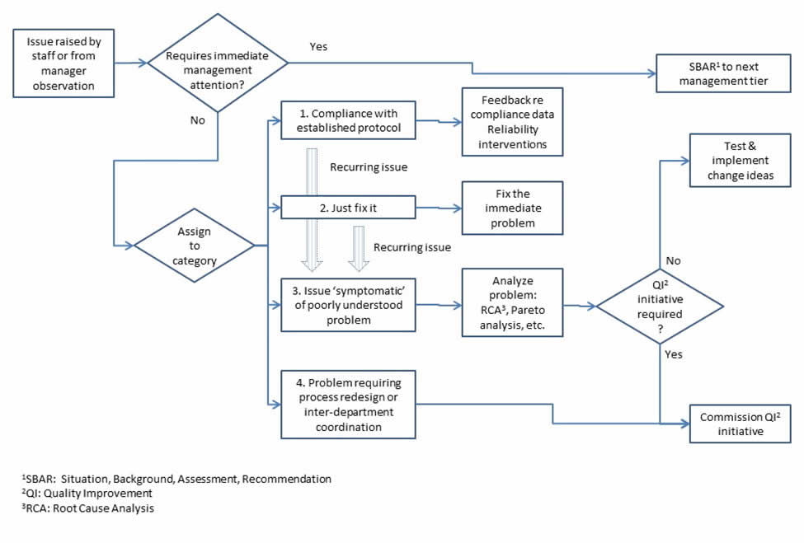

1. **Revision procedures for this document:**

* Revision to this plan will be approved by the project manager. The revision number and date will be clearly mentioned at the top of the document.
* The project manager would no doubt require making certain revision to the project schedule and the budgetary and resource requirements of the project.
* These revisions are made, in general, by considering the current status of the project and the advancement that should have been made to the project in the time that has elapsed from the day the project has started
* Thus, the project manager has to consider the details of the status reports generated by the sub team and consider whether any revisions have to be made.
* In case any such revised plan has to be formulated, all the stakeholders associated with the project need to be communicated of the changes being made, along with the reasons behind such revisions and the consequences of these revisions

1. **Glossary of common terminology:**

* Virtual team: Group of people work together across time and space boundaries using communication technologies.
* Brainstorming: A technique to foster the productivity of the group by encouraging the group members to express their ideas.
* Document Management system: Document Management system provides a platform for organizing all paper and digital documents.
* Daily emails: As needed for the development team so as to show their progress to the stakeholders.
* SBAR: Situation, Background, Assessment, Recommendation so as describe the problem to the next-level manager and recommend a course of action.
* Baseline: The original project plan plus approved changes
* QI : Quality Improvement
* RCA : Root Cause Analysis